NEWSLETTER ARTICLE ABOUT THE PLEDGE

On ________[date], we [organization name] joined youth serving organizations all across central Indiana in taking the Jump IN Pledge for Youth Organizations. Our organization believes that all children deserve the opportunity to be healthy and successful.
We have pledged to do our part to help students make healthy choices by doing the following things:
- We will serve healthy meals, snacks and beverages at our gatherings.
- We will give our young people opportunities to play and be active when they are with us.
- We will teach our young people to make healthy choices to eat nutritious foods and be physically active.
- We will encourage parents and caregivers to promote healthy habits at home.
You can learn more about the Jump IN Pledge at www.JumpINPledge.org.
We will be promoting the 5-2-1-0 Every Day message:
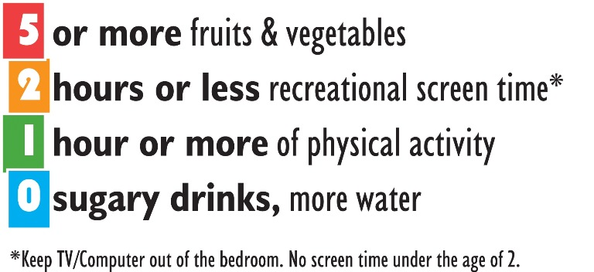
The Jump IN website contains great tools and resources for incorporating these goals into daily living. We are working to align our policies and practices with these principles with the goal of making the healthy choice the easy choice for our youth when they are in our care.
Together we can create a healthy environment where our young people can lead active and healthy lives!
[other graphics for the newsletter – jpeg files]

