MESSAGE FOR FAMILIES ABOUT THE PLEDGE
[Date]
Dear Families:
[Our organization] believes that all children deserve the opportunity to be healthy and successful. Healthy eating and physical activity improve concentration, memory, and mood, helping students become better learners.
To support healthy students and families, we have taken the Jump IN Pledge for Youth Organizations and will do our part to help our children and youth make healthy choices:
- We will serve healthy meals, snacks and beverages at our gatherings.
- We will give our young people opportunities to play and be active when they are with us.
- We will teach our young people to make healthy choices to eat nutritious foods and be physically active.
- We will encourage parents and caregivers to promote healthy habits at home.
We are joining other youth organizations, schools, child care providers, and out of school programs in promoting the 5-2-1-0 Every Day message:
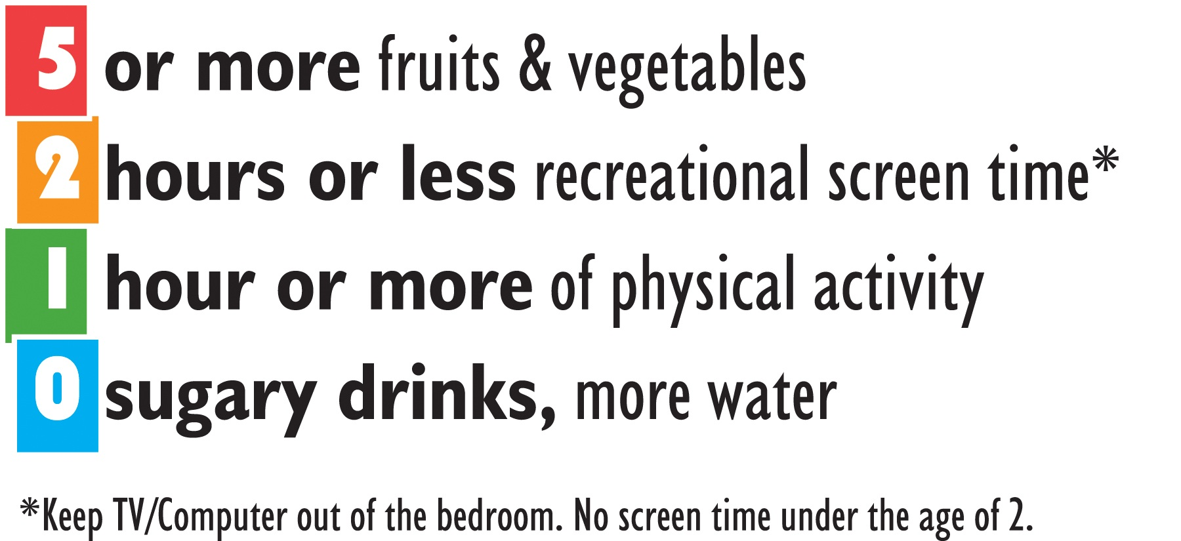
Your young person will receive more information about 5-2-1-0 throughout the year. If you have any questions please don’t hesitate to contact us. If you would like more information about the Jump IN Pledge visit www.JumpInPledge.org. Thank you for your support in helping us create a healthier place where our children and youth can lead active and healthy lives!
Sincerely,

