NEWSLETTER ARTICLE ABOUT THE PLEDGE

On ________[date], our school joined schools all across central Indiana in taking the Jump IN Pledge for Schools. We have pledged to do our part to help students make healthy choices by doing the following things:
- We will serve healthy meals and beverages in our cafeteria.
- We will promote healthy snacks in our classrooms, vending machines, concession stands and fundraisers.
- We will ensure that our students are physically active for at least 30 minutes during the school day.
- We will teach our young people to make healthy choices to eat nutritious foods and be physically active.
- We will encourage parents and caregivers to promote healthy habits at home.
You can learn more about the Jump IN Pledge at www.JumpINPledge.org. We will be promoting the 5-2-1-0 Every Day message:
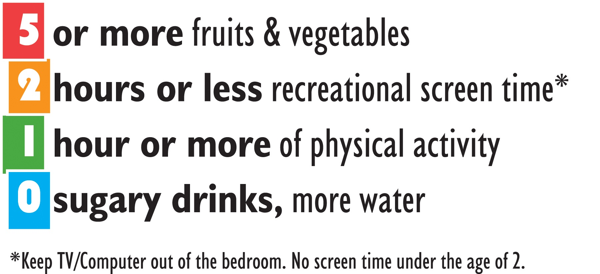
Our school believes that all children deserve the opportunity to be healthy and successful. Healthy eating and physical activity improve concentration, memory, and mood, helping students become better learners. Together we can create a healthier place for our students to learn!
[other graphics for the newsletter – jpeg files]
