NEWSLETTER ARTICLE ABOUT THE PLEDGE

On ________[date], our school joined other providers all across central Indiana in taking the Jump IN Pledge for Child Care Providers. We have pledged to do our part to help students make healthy choices by doing the following things:
- We will serve healthy meals, snacks and beverages.
- We will ensure that our students are physically active in age-appropriate ways for at least 30 minutes for every half day of care.
- We will model healthy eating habits for our children.
- We will incorporate recommended nutrition and physical activity guidelines into our policies and practices.
- We will encourage parents and caregivers to promote healthy habits at home.
You can learn more about the Jump IN Pledge at www.JumpINPledge.org. We will be promoting the 5-2-1-0 Every Day message:
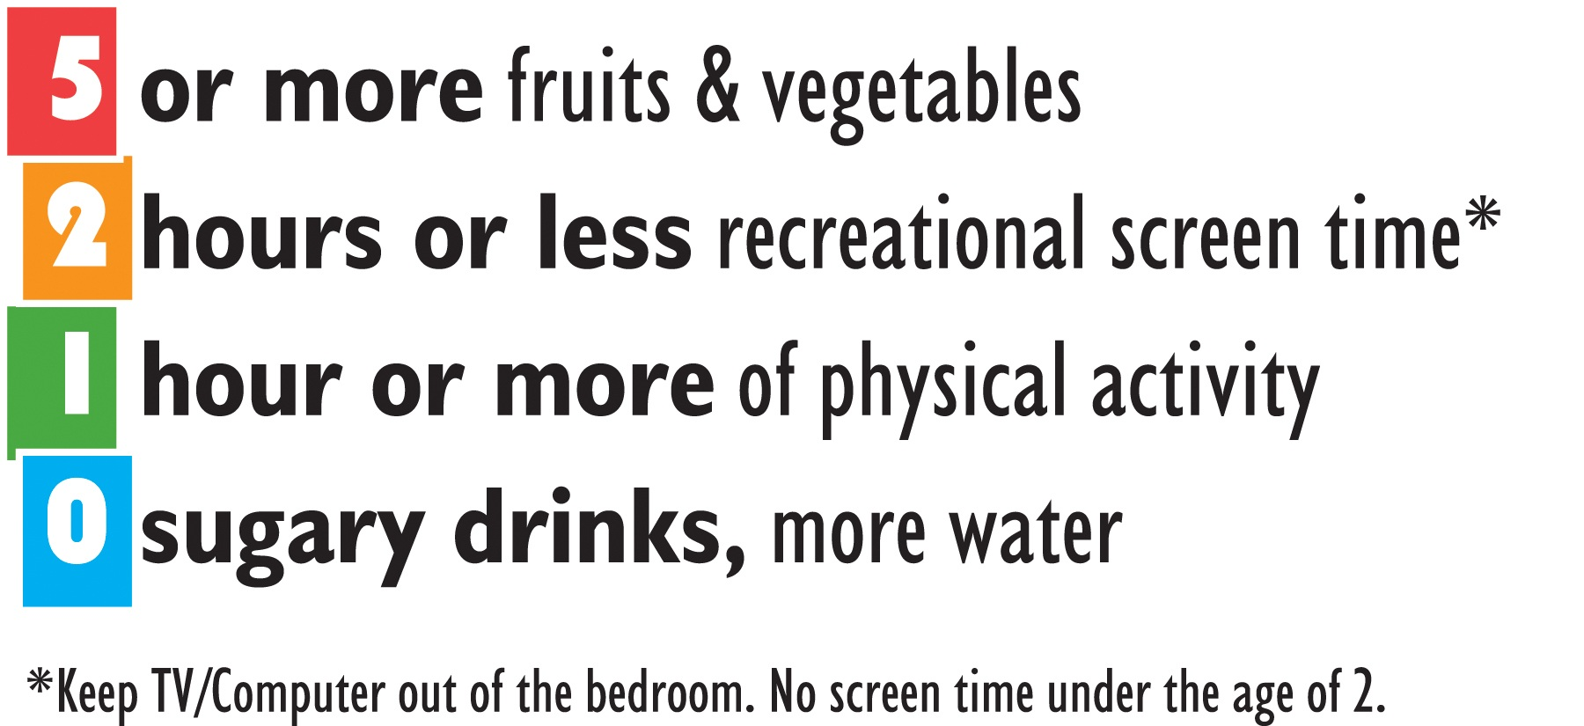
Our school believes that all children deserve the opportunity to be healthy and successful. Healthy eating and physical activity improve concentration, memory, and mood, helping students become better learners. Together we can create a healthier place for our students to learn!
[other graphics for the newsletter – jpeg files]

